**ASSIGNMENT-4**

* Sequence Diagram

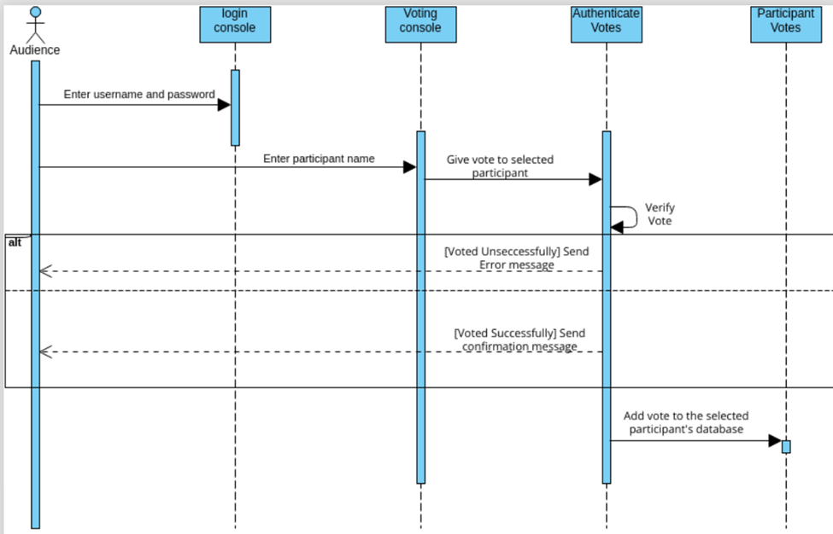

* Collaboration Diagram

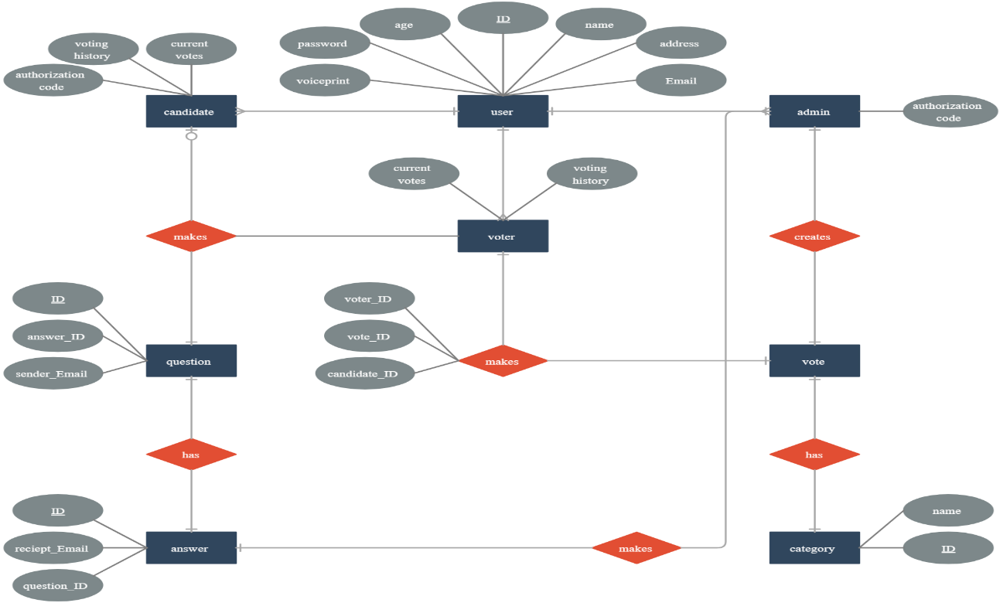

* Activity Diagram

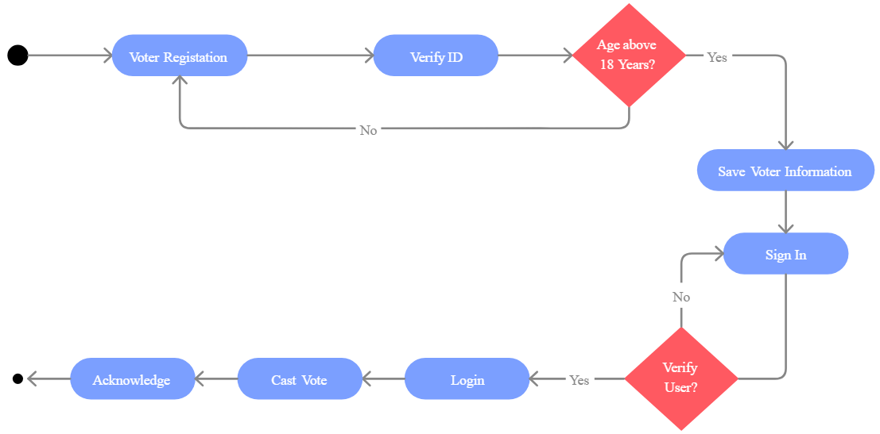

* State Chart Diagram

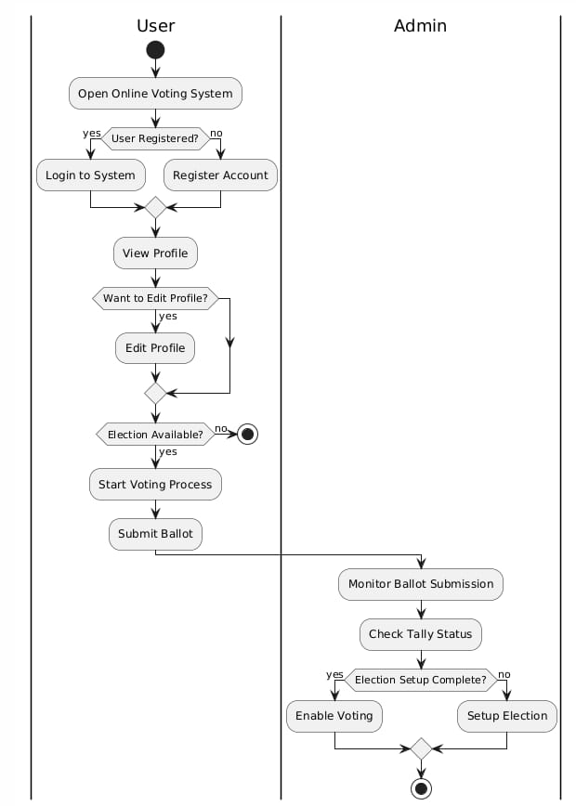

* Component Diagram

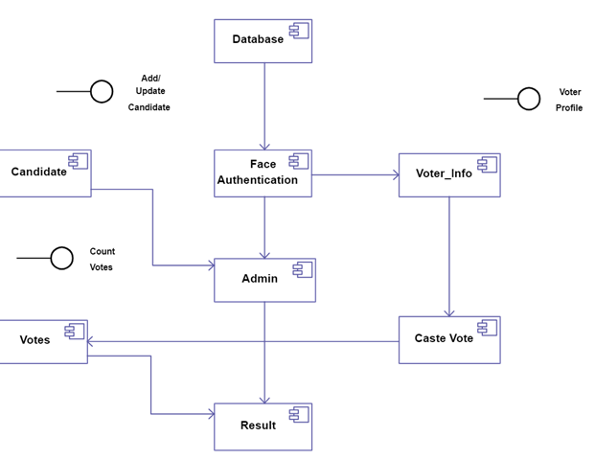

* Deployment Diagram

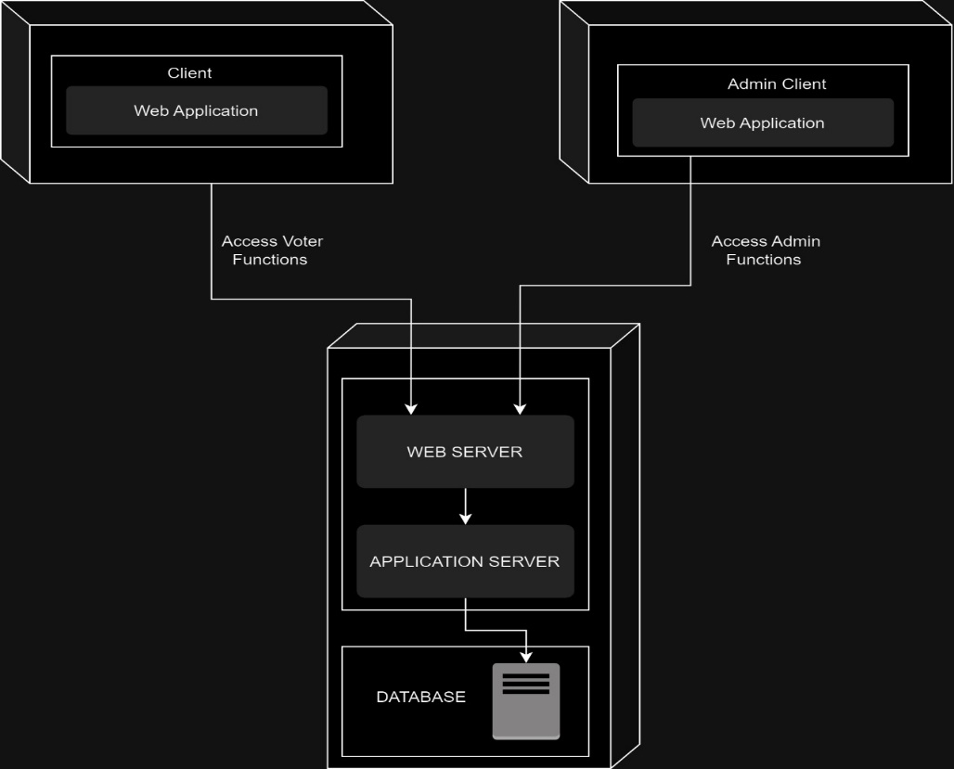

BY

R.SAI SHARAD

MITHUL

E. ABHIRAM

SUMANTH

GNANPRAKASH